Instructional Materials
The below guide will introduce you to the basics of Spark. You’ll learn how to login, create a new account, reset your password, join a new community, or post a message to a community. You may also watch a video tutorial here. If you have any questions or technical difficulties, please contact us at spark@cswe.org.

How to Login
- Navigate to spark.cswe.org.
- In the top right-hand corner of the page, click the blue Sign in button.
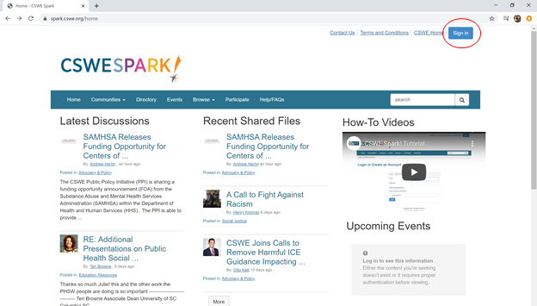
- Enter your login credentials in the Email and Password fields.
- Click the blue Login button.
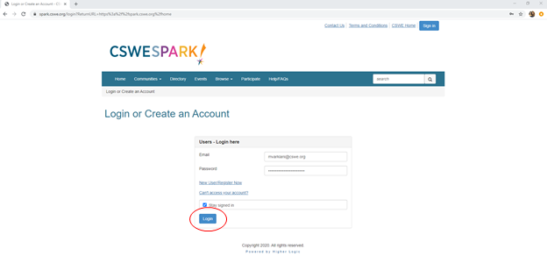

How to Reset Your Password
- Navigate to spark.cswe.org.
- In the top right-hand corner of the page, click the blue Sign in button.
- Under the Password field, click the Can’t access your account? Link.
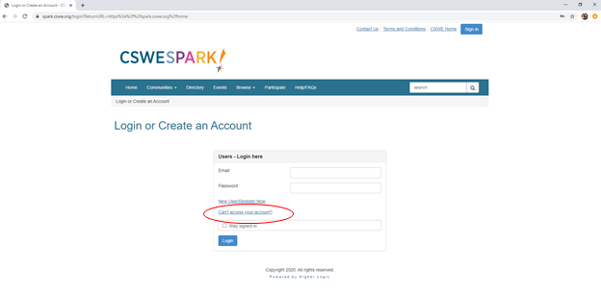
- Enter the email address associated with your Spark account, and click the blue Send Password Link button.

How to Create a New Account
- Navigate to spark.cswe.org.
- In the top right-hand corner of the page, click the blue Sign in button.
- Under the Password field, click the New User/Register Now link.
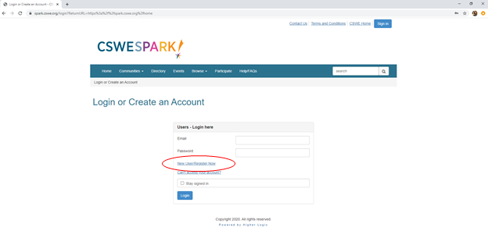
- Fill out the form with your email address, first and last name, and desired password. The fields marked with a red asterisk are mandatory.
- Click the blue Create Account button.
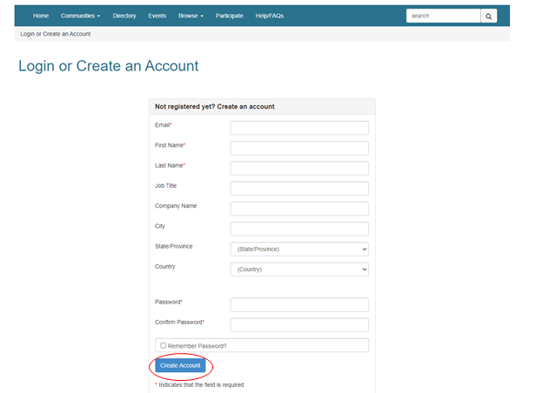
- Navigate to your email inbox. Find the email with the subject line “Action Required to Activate your spark.cswe.org profile.” Follow the instructions in the email to activate your profile.
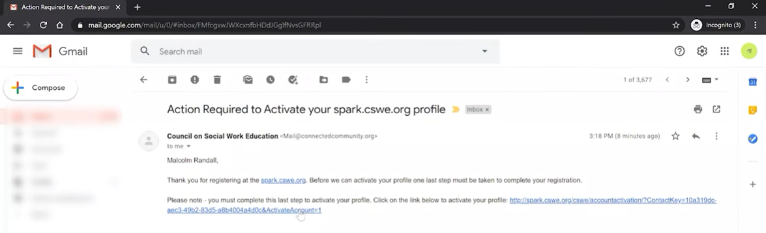
NOTE: A Spark administrator must approve your account before you are able to login and gain access to the platform. You will receive an email once your account is approved.

How to Join a New Community
- Create a new account or login to an existing Spark account.
- Click on the Communities tab in the navigation menu, and choose the All Communities link from the drop-down menu.
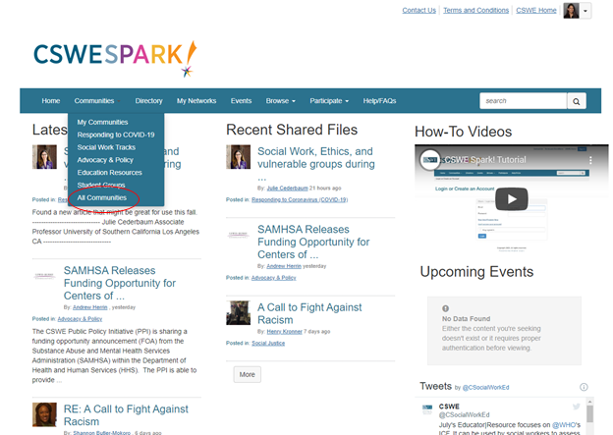
- From this page, you can sort, filter, and select which communities to join.
- Click the blue Join button to the right of the community name.
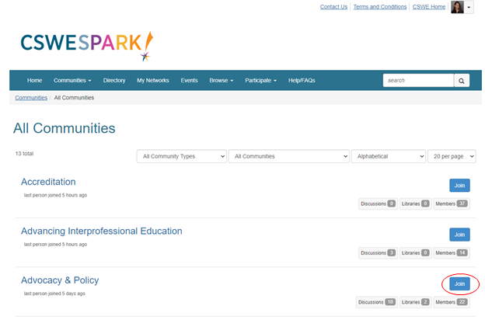
How to Post a Message to a Community
There are three ways to post a new message to a community.
Method One
- Click on the Participate tab in the navigation menu, and choose the Post a Message link from the drop-down menu.
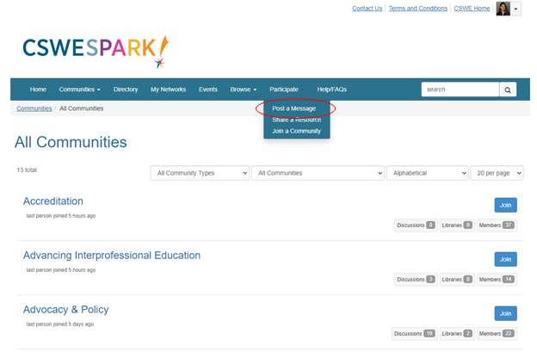
- In the To field, select which community you would like to post a message to. Fill out the Subject field, and craft your message in the white box.
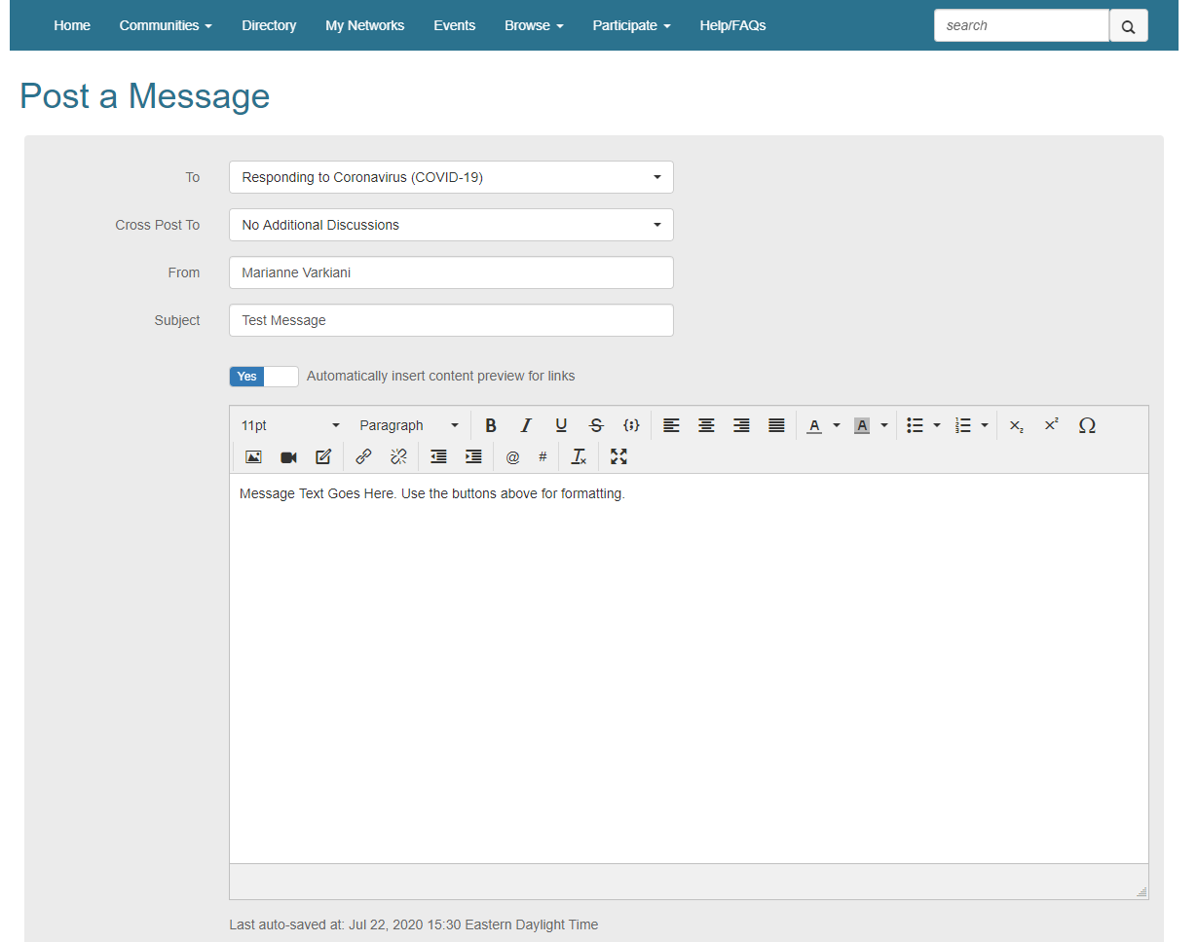
- To attach a file with your message, click the white Attach button.
- Click the blue Send button to post your message immediately. Alternatively, you may click the Schedule button to post your message at a later date. If you’re not ready to post yet, click the Save as Draft button to save your changes.
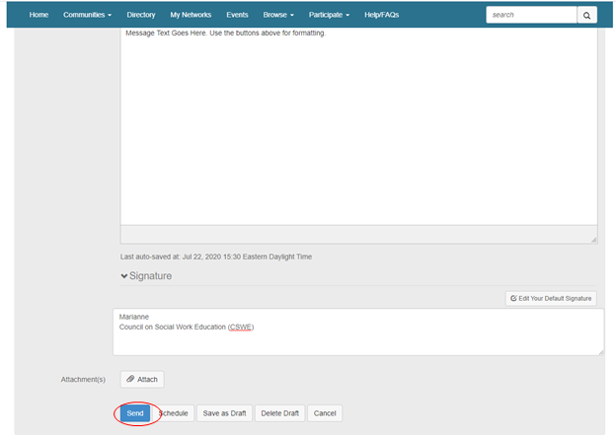
Method Two
- Navigate to the community you would like to post a message in.
- Next to Latest Discussion Posts, click the green Add button. Follow the steps under the “Method One” section.
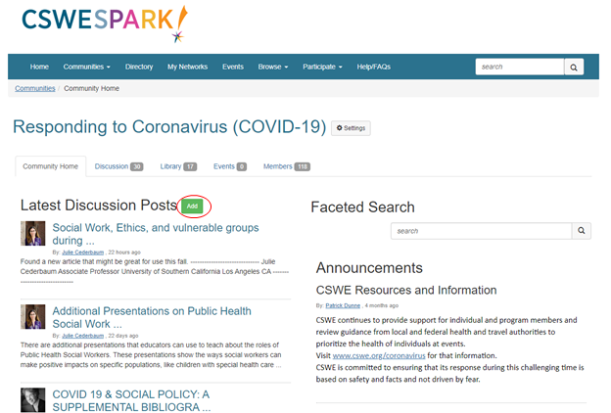
Method Three
- Navigate to the community you would like to post a message in.
- Click the Discussions tab, then click the green Post New Message button. Follow the steps under the “Method One” section.
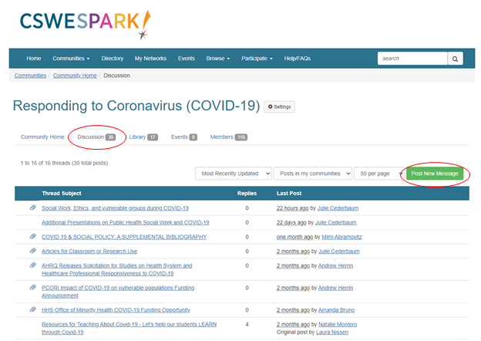

How to Invite Members to a Private Community
Strictly for chairs and co-chairs of CSWE’s commission and councils.
- Navigate to your governance community.
- Click the Settings button next to the name of the community.
- In the box that pops up, select the button labeled Invite Others to Join.
- Select the members (or Contacts) that you would like to invite by checking the boxes next to each name or by pressing the Check all button. Any users that you wish to invite must be Contacts before you can have the ability to invite them.
- Craft a personalized Invitation Message and click Send Invitation.
